**MY DESIGN:**

**Main XML**

<?xml version="1.0" encoding="utf-8"?>  
<androidx.constraintlayout.widget.ConstraintLayout xmlns:android="http://schemas.android.com/apk/res/android"  
 xmlns:app="http://schemas.android.com/apk/res-auto"  
 xmlns:tools="http://schemas.android.com/tools"  
 android:layout_width="match_parent"  
 android:layout_height="match_parent"  
 tools:context=".MainActivity">  
  
 <TextView  
 android:id="@+id/textView"  
 android:layout_width="wrap_content"  
 android:layout_height="wrap_content"  
 android:text="Latitude: | Longitude:"  
 app:layout_constraintBottom_toBottomOf="parent"  
 app:layout_constraintEnd_toEndOf="parent"  
 app:layout_constraintHorizontal_bias="0.467"  
 app:layout_constraintStart_toStartOf="parent"  
 app:layout_constraintTop_toTopOf="parent" />  
  
 <Button  
 android:id="@+id/button"  
 android:layout_width="wrap_content"  
 android:layout_height="wrap_content"  
 android:layout_marginStart="116dp"  
 android:layout_marginTop="188dp"  
 android:onClick="buttonGetLocation"  
 android:text="Get Location"  
 app:layout_constraintStart_toStartOf="parent"  
 app:layout_constraintTop_toTopOf="parent" />  
  
 <EditText  
 android:id="@+id/editTextTextPersonName"  
 android:layout_width="wrap_content"  
 android:layout_height="wrap_content"  
 android:layout_marginStart="94dp"  
 android:layout_marginTop="61dp"  
 android:ems="10"  
 android:hint="Address"  
 android:inputType="textPersonName"  
 android:minHeight="48dp"  
 app:layout_constraintStart_toStartOf="parent"  
 app:layout_constraintTop_toTopOf="parent" />  
  
 <Button  
 android:id="@+id/button2"  
 android:layout_width="wrap_content"  
 android:layout_height="wrap_content"  
 android:layout_marginStart="148dp"  
 android:layout_marginTop="100dp"  
 android:layout_marginEnd="148dp"  
 android:text="Exit"  
 app:layout_constraintEnd_toEndOf="parent"  
 app:layout_constraintStart_toStartOf="parent"  
 app:layout_constraintTop_toBottomOf="@+id/textView" />  
  
</androidx.constraintlayout.widget.ConstraintLayout>

**Main Java:**

package com.example.getlatitudelongitude;  
  
import androidx.appcompat.app.AppCompatActivity;  
  
import android.location.Address;  
import android.location.Geocoder;  
import android.os.Bundle;  
import android.view.View;  
import android.widget.EditText;  
import android.widget.TextView;  
  
import java.io.IOException;  
import java.util.List;  
  
public class MainActivity extends AppCompatActivity {  
  
 private EditText editText;  
 private TextView textView;  
  
 @Override  
 protected void onCreate(Bundle savedInstanceState) {  
 super.onCreate(savedInstanceState);  
 setContentView(R.layout.*activity_main*);  
  
  
 editText = findViewById(R.id.*editTextTextPersonName*);  
 textView = findViewById(R.id.*textView*);  
  
 }  
  
 public void buttonGetLocation (View view){  
  
 Geocoder geocoder = new Geocoder(this);  
 List<Address> addressList;  
  
 try {  
 addressList = geocoder.getFromLocationName(editText.getText().toString(), 1);  
  
 if (addressList != null){  
 double doubleLat = addressList.get(0).getLatitude();  
 double doubleLong = addressList.get(0).getLongitude();  
  
 textView.setText("Latitude: " + String.*valueOf*(doubleLat)  
 + " | " + "Longitude: " + String.*valueOf*(doubleLong));  
 }  
  
 } catch (IOException e) {  
 e.printStackTrace();  
 }  
  
 }  
}

**Outcome – Design & Studio Emulator Pixel 4 API 25:**

**Performed Test:**

* Successful Test
* Auto populated the Latitude and Longitude for location Jacksonville, FL

* Clicked Exit
* Android Main page.

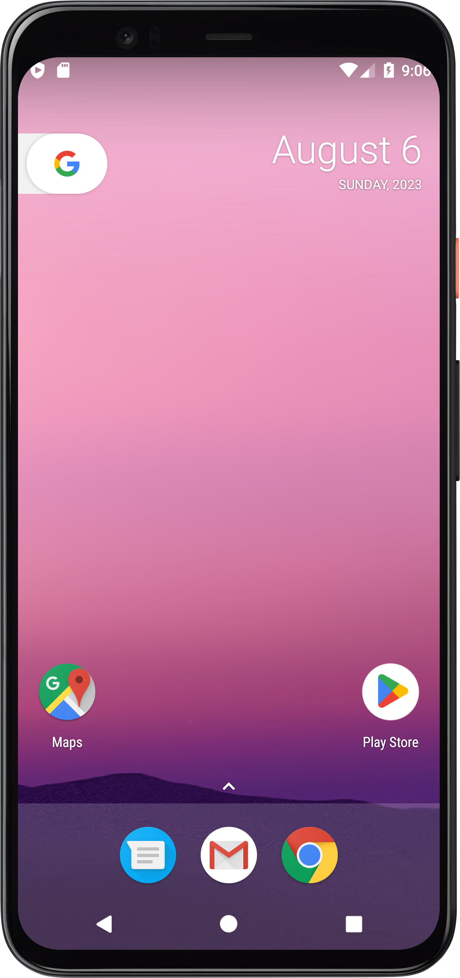

* Click the upper arrow.

* Displays all Android Applications.

* Click any desired application – example Camera.

* Click the left arrow to take you to the main applications.

